**Pengenalan Mikrokontroler**

1. **Teori Dasar**

Mikrokontroler

mikrokontroller adalah komputer yang berukuran mikro dalam satu chip IC (integrated circuit) yang terdiri dari processor, memory, dan antarmuka yang bisa diprogram. Jadi disebut komputer mikro karena dalam IC atau chip mikrokontroller terdiri dari CPU, memory, dan I/O yang bisa kita kontrol dengan memprogramnya. I/O juga sering disebut dengan GPIO (General Purpose Input Output Pins) yang berarti : pin yang bisa kita program sebagai input atau output sesuai kebutuhan.

Arduino Mega 2560

Arduino Mega 2560 adalah Board pengembangan mikrokontroller yang berbasis Arduino dengan menggunakan chip ATmega2560. Board ini memiliki pin I/O yang cukup banyak, Tentunya versi Arduino mega lebih memberikan peluang dalam Rancang bangun sistem yang lebih besar.

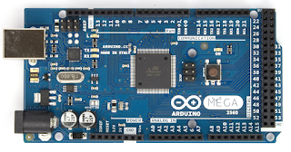

|  |  |
| --- | --- |
| ****SPESIFIKASI**** | |
| ****Arduino Mega**** | |
| Microcontroller | ATmega2560 |
| Operating Voltage | 5V |
| Input Voltage (recommended) | 7-12V |
| Input Voltage (limit) | 6-20V |
| Digital I/O Pins | 54 (of which 15 provide PWM output) |
| Analog Input Pins | 16 |
| DC Current per I/O Pin | 20 mA |
| DC Current for 3.3V Pin | 50 mA |
| Flash Memory | 256 KB of which 8 KB used by bootloader |
| SRAM | 8 KB |
| EEPROM | 4 KB |
| Clock Speed | 16 MHz |
| LED_BUILTIN | 13 |
| Length | 101.52 mm |
| Width | 53.3 mm |
| Weight | 37 g |

Pin pada Mikrokontroler Arduino terbagi atas empat jenis pin di antanya:

1. pin digital

pin digital merupakan pin yang dapat menerima sinyal digital (digital input) dan menghasilkan sinyal digital (digital output).

1. pin analog

pin analog yaitu pin yang dapat menerima sinyal analog (analog input) dan menghasilkan sinyal analog(analog output / PWM).

1. pin komunikasi

pin comunikasi merupankan pin yang digunakan untuk berkomunikasi dengan komputer lain.

1. pin power

pin power merupakan pin catu daya baik berupa catu daya masuk atau keluar.

perhatikan gambar berikut :

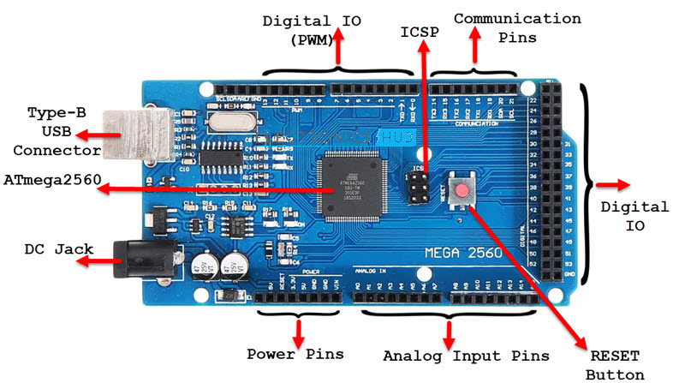

Arduino IDE

Arduino IDE adalah *software* atau perangkat lunak yang digunakan untuk membuat *sketch* atau kode pemrogaman sebagai perintah *untuk melakukan sesuatu.* adapun menu-menu yang dimiliki arduino IDE sebagai berikut :

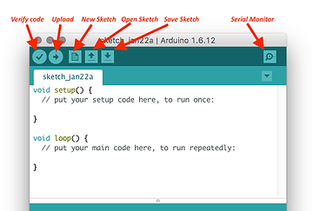

1. verify

menu verify berfungsi untuk memverifikasi atau memeriksa apakah program yang dibuat di tema atau tidak.

1. upload

menu untuk mengupload atau memasang kode program yang telah selesai dibuat ke board Arduino

1. new sketch

menu new sketch berfungsi untuk membuat file program baru.

1. open sketch

menu open sketch berfugsi untuk membuka file program yang telah tersimapan sebelumnya.

1. save sketch

menu save sketch berfungsi untuk menyimpan hasil perubahan kode program.

1. serial monitor

menu serial monitor berfungsi membuka serial monitor untuk menampilkan sebuah jendela yang dikirimkan atau di terima.

1. **pertanyaan siswa**

_ _ _ _ _ _ _ _ _ _ _ _ _ _ _ _ _ _ _ _ _ _ _ _ _ _ _ _ _ _ _ _ _ _ _ _ _ _ _ _ _ _ _ _ _ _ _ _ _ _ _ _ _ _ _ _ _ _ _ _ _ _ _ _ _ _ _ _ _ _ _ _ _ _ _ _ _ _ _ _ _ _ _ _ _ _ _ _ _ _ _ _ _ _ _ _ _ _ _ _ _ _ _ _ _ _ _ _ _ _ _ _ _ _ _ _ _ _ _ _ _ _ _ _ _ _ _ _ _ _ _ _ _ _ _ _ _ _ _ _ _ _ _ _ _ _ _ _ _ _ _ _ _ _ _ _ _ _ _ _ _ _ _ _ _ _ _ _ _ _ _ _ _ _ _ _ _ _ _ _ _ _ _ _ _ _ _ _ _ _ _ _ _ _ _ _ _ _ _ _ _ _ _ _ _ _ _ _ _ _ _ _ _ _ _ _ _ _ _ _ _ _ _ _ _ _ _ _ _ _ _ _ _ _ _ _ _ _ _ _ _ _ _ _ _ _ _ _ _ _ _ _ _ _ _ _ _ _ _ _ _ _ _ _ _ _ _ _ _ _ _ _ _ _ _ _ _ _ _ _ _ _ _ _ _ _ _ _ _ _ _ _ _ _ _ _ _ _ _ _ _ _ _ _ _ _ _ _ _ _ _ _ _ _ _ _ _ _ _ _ _ _ _ _ _ _ _ _ _ _ _ _ _ _ _ _ _ _ _ _ _ _ _ _ _ _ _ _ _ _ _ _ _ _ _ _ _ _ _ _ _ _ _ _ _ _ _ _ _ _ _ _ _ _ _ _ _ _ _ _ _ _ _ _ _ _ _ _ _ _ _ _ _ _ _ _ _ _ _ _ _ _ _ _ _ _ _ _ _ _ _ _ _ _ _ _ _ _ _ _ _ _ _ _ _ _ _ _ _ _ _ _ _ _ _ _ _ _ _ _ _ _ _ _ _ _ _ _ _ _ _ _ _ _ _ _ _ _ _ _ _ _ _ _ _ _ _ _ _ _ _ _ _ _ _ _ _ _ _ _ _ _ _ _ _ _ _ _ _ _ _ _ _ _ _ _ _ _ _ _ _ _ _ _ _ _ _ _ _ _ _ _ _ _ _ _ _ _ _ _ _ _ _ _ _ _ _ _ _ _ _ _ _ _ _ _ _ _ _ _ _ _ _ _ _ _ _ _ _ _ _ _ _ _ _ _ _ _ _ _ _ _ _ _ _ _ _ _ _ _ _ _ _ _ _ _ _ _ _ _ _ _ _ _ _ _ _ _ _ _ _ _ _ _ _ _ _ _ _ _ _ _ _ _ _ _ _ _ _ _ _ _ _ _ _ _ _ _ _ _ _ _ _ _ _ _ _ _ _ _ _ _ _ _ _ _ _ _ _ _ _ _ _ _ _ _ _ _ _ _ _ _ _ _ _ _ _ _ _ _ _ _ _ _ _ _ _ _ _ _ _ _ _ _ _ _ _ _ _ _ _ _ _ _ _ _ _ _ _ _ _ _ _ _ _ _ _ _ _ _ _ _ _ _ _ _ _ _ _ _ _ _ _ _ _ _ _ _ _ _ _ _ _ _ _ _ _ _ _ _ _ _ _ _ _ _ _ _ _ _ _ _ _ _ _ _ _ _ _

**Praktekum 1**

**Membuat Code Program**

1. Environment

Arduino Mega 2560

PC / Laptop

Ardino IDE

1. Langkah Kegiatan
2. Sambungkan Board Arduino Mega 2560 ke PC / Laptop menggunakan kabel USB
3. Sebagai awal dari project kedepan buka PC / Laptop buat 1 buah folder di dalam Document dengan nama : Robotika dan Otomasi.
4. Buka Arduino IDE, patikan tampilan nya akan tampak sebagai berikut:

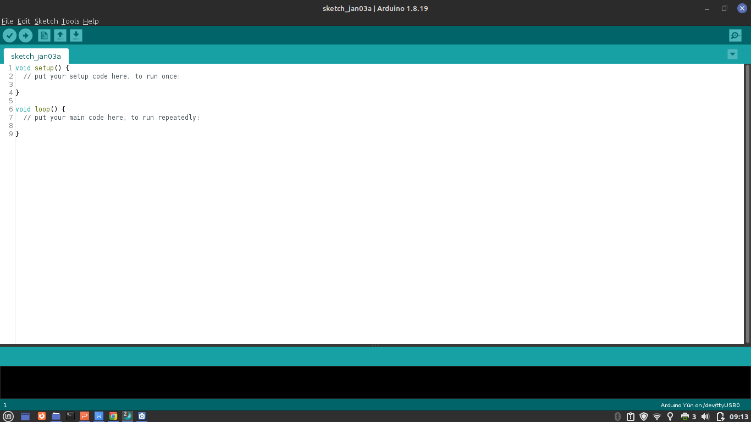

1. ubah isi code program di atas dengan kede berikut:

void setup() {

Serial.begin(9600);

}

void loop() {

Serial.println("Hallo.. saya sedang belajar Robotika dan Otomasi");

delay(1000);

}

1. Kemudian Klik File -> Save -> arahkan ke folder Robotika dan Otomasi -> ubah nama file menjadi : praktikum1
2. pastikan pemilihan board sudah sesuai : arduino mega 2560
3. pastikan pemilihan port yang terhubung sedah benar misalnya : COM5
4. upload code program dengan cara klik menu upload
5. cek serial monitor untuk mengetahui apakah program berjalan dengan baik, jika berhasil akan tampak sebagai berikut:

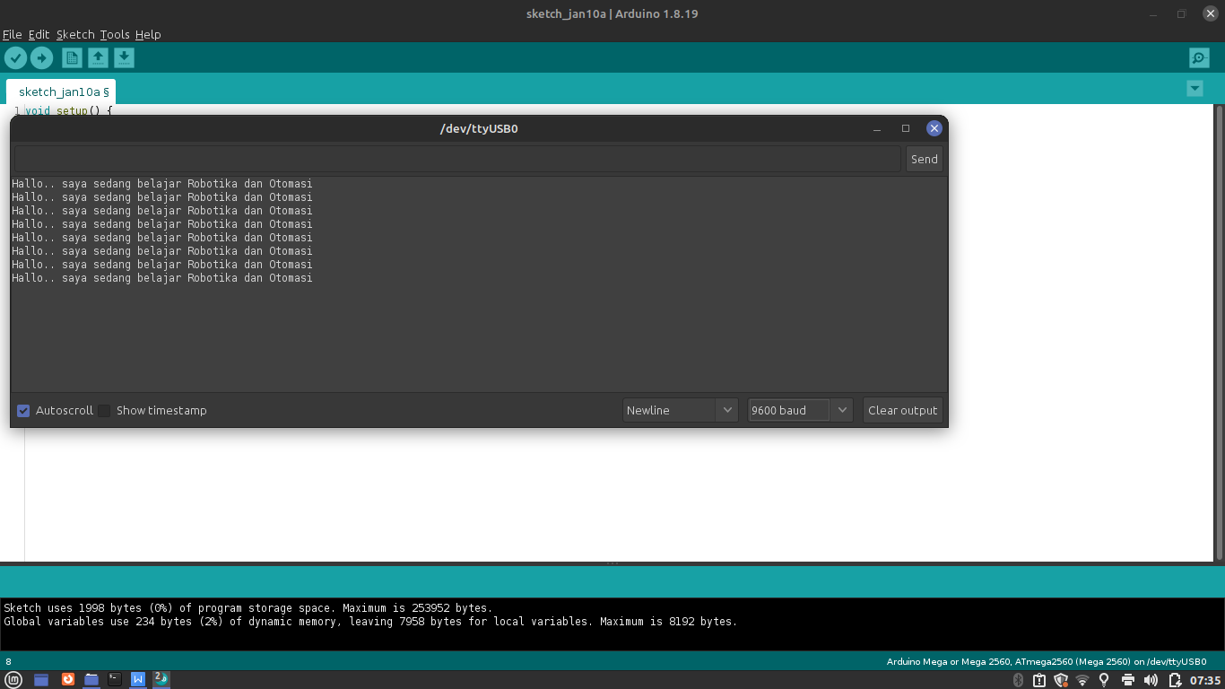

1. Analisis

lakukan langkah kegiatan di atas sebanyak minimal 5 kali percobaan kemudian isi analisa tabel berikut:

|  |  |  |  |
| --- | --- | --- | --- |
| No Percobaan | Waktu (Menit) | Keterangan (Sukses / Gagal) | Paraf Guru |
| 1 |  |  |  |
| 2 |  |  |  |
| 3 |  |  |  |
| 4 |  |  |  |
| 5 |  |  |  |
| 6 |  |  |  |
| 7 |  |  |  |
| 8 |  |  |  |
| 9 |  |  |  |
| 10 |  |  |  |

1. Kesimpulan

- - - - - - - - - - - - - - - - - - - - - - - - - - - - - - - - - - - - - - - - - - - - - - - - - - - - - - - - - - - - - - - - - - - - - - - - - - - - - - - - - - - - - - - - - - - - - - - - - - - - - - - - - - - - - - - - - - - - - - - - - - - - - - - - - - - - - - - - - - - - - - - - - - - - - - - - - - - - - - - - - - - - - - - - - - - - - - - - - - - - - - - - - - - - - - - - - - - - - - - - - - - - - - - - - - - - - - - - - - - - - - - - - - - - - - - - - - - - - - - - - - - - - - - - - - - - - - - - - - - - - - - - - - - - - - - - - - - - - - - - - - - - - - - - - - - - - - - - - - - - - - - - - - - - - - - - - - - - - - - - - - - - - - - - - - - - - - - - - - - - - - - - - - - - - - - - - - - - - - - - - - - - - - - - - - - - - - - - - - - - - - - - - - - - - - - - - - - - - - - - - - - - - - - - - - - - - - - - - - - - - - - - - - - - - - - - - - - - - - - - - - - - - - - - - - - - - - - - - - - - - - - - - - - - - - - - - - - - - - - - - - - - - - - - - - - - - - - - - - - - - - - - - - - - - - - - - - - - - - - - - - - - - - - - - - - - - - - - - - - - - - - - - - - - - - - - - - - - - - - - - - - - - - - - - - - - - - - - - - - - - - - - - - - - - - - - - - - - - - - - - - - - - - - - - - - - - - - - - - - - - - - - - - - - - -

**Pernyataan ( ; ) dan Komentar ( // , /* */)**

1. **Teori Dasar**

Pernyataan

Pernyataan (statement) adalah kode program yang merupakan suatu perintah terhadap komputer untuk menjalankan sesuatu. tanda dari sebuah pernyataan biasanya di akhir baris kode program diakhiri dengan titik koma (;).

Komentar

komentar merupakan bagian dari kode program yang tidak di jalankan oleh komputer biasanya digunakan untuk memberi tanda atau keterangan pada program yang dibuat. tanda dari sebuah komentar biasanya di awal baris kode di awali dengan dua garis miring (//) atau di awali dengan garis miring bintang ( /* ) dan di akhiri dengan bintang garis miring (*/) jika komentar lebih dari satu baris.

perharikan contoh program berikut :

|  |  |
| --- | --- |
| 1  2  3  4  5  6  7  8  9  10  11  12  13  14  15  16 | /*  Program 1  LED Blink  */  void setup() {  // perintah menjadikan pin 13 sebagai OUTPUT  pinMode(13, OUTPUT);  }  void loop() {  digitalWrite(13, HIGH) ; // LED menyala  delay(1000); // waktu tunda 1 detik  digitalWrite(13, LOW) ; // LED mati  delay(1000); // waktu tunda 1 detik  } |

Dari hasil analisa dari kode program diatas disimpukan :

1. pada bagian baris kode 1 sampai 4 merupakan sebuah komentar dikarnakan dilihat dari tandanya yaitu di awali dengan /* dan di akhiri */,
2. pada bagian baris kode ke 7 juga di sebut sebagai komentar karena di awal baris kodenya di awali dengan //,
3. pada bagian baris kode ke 8 disebut dengan pernyataan karena pada bagian akhir kodenya di akhir dengan (;),
4. pada bagian baris kode ke 12,13,14 dan 15 pada bagian sebelum (;) di sebut pernyataan sedangkan setelah // di sebut dengan komentar.

Berikut beberapa pernyataan dasar yang perlu diketahui beserta dengan fungsinya :

|  |  |  |
| --- | --- | --- |
| **Pernyataan (statement)** | **Fungsi** | **Contoh** |
| pinMode(no_pin, INPUT/OUTPUT); | Menjadikan pin sebagai input atau output | pinMode(12, OUTPUT); |
| digitalWrite(no_pin, HIGH/LOW); | mengeluarkan sinyal digital dari pin tertentu | digtalWrite(3, LOW); |
| digitalRead(no_pin); | membaca sinyal digital dari pin tertentus | digitalRead(5); |
| analogWrite(no_pin, 0 - 255); | mengeluarkan sinyal analog pada pin tertentu. | analogWrite(11,35); |
| analogRead(no_pin); | membaca sinyal analog pada pin tertentu. | analogRead(A0); |

1. **pertanyaan siswa**

_ _ _ _ _ _ _ _ _ _ _ _ _ _ _ _ _ _ _ _ _ _ _ _ _ _ _ _ _ _ _ _ _ _ _ _ _ _ _ _ _ _ _ _ _ _ _ _ _ _ _ _ _ _ _ _ _ _ _ _ _ _ _ _ _ _ _ _ _ _ _ _ _ _ _ _ _ _ _ _ _ _ _ _ _ _ _ _ _ _ _ _ _ _ _ _ _ _ _ _ _ _ _ _ _ _ _ _ _ _ _ _ _ _ _ _ _ _ _ _ _ _ _ _ _ _ _ _ _ _ _ _ _ _ _ _ _ _ _ _ _ _ _ _ _ _ _ _ _ _ _ _ _ _ _ _ _ _ _ _ _ _ _ _ _ _ _ _ _ _ _ _ _ _ _ _ _ _ _ _ _ _ _ _ _ _ _ _ _ _ _ _ _ _ _ _ _ _ _ _ _ _ _ _ _ _ _ _ _ _ _ _ _ _ _ _ _ _ _ _ _ _ _ _ _ _ _ _ _ _ _ _ _ _ _ _ _ _ _ _ _ _ _ _ _ _ _ _ _ _ _ _ _ _ _ _ _ _ _ _ _ _ _ _ _ _ _ _ _ _ _ _ _ _ _ _ _ _ _ _ _ _ _ _ _ _ _ _ _ _ _ _ _ _ _ _ _ _ _ _ _ _ _ _ _ _ _ _ _ _ _ _ _ _ _ _ _ _ _ _ _ _ _ _ _ _ _ _ _ _ _ _ _ _ _ _ _ _ _ _ _ _ _ _ _ _ _ _ _ _ _ _ _ _ _ _ _ _ _ _ _ _ _ _ _ _ _ _ _ _ _ _ _ _ _ _ _ _ _ _ _ _ _ _ _ _ _ _ _ _ _ _ _ _ _ _ _ _ _ _ _ _ _ _ _ _ _ _ _ _ _ _ _ _ _ _ _ _ _ _ _ _ _ _ _ _ _ _ _ _ _ _ _ _ _ _ _ _ _ _ _ _ _ _ _ _ _ _ _ _ _ _ _ _ _ _ _ _ _ _ _ _ _ _ _ _ _ _ _ _ _ _ _ _ _ _ _ _ _ _ _ _ _ _ _ _ _ _ _ _ _ _ _ _ _ _ _ _ _ _ _ _ _ _ _ _ _ _ _ _ _ _ _ _ _ _ _ _ _ _ _ _ _ _ _ _ _ _ _ _ _ _ _ _ _ _ _ _ _ _ _ _ _ _ _ _ _ _ _ _ _ _ _ _ _ _ _ _ _ _ _ _ _ _ _ _ _ _ _ _ _ _ _ _ _ _ _ _ _ _ _ _ _ _ _ _ _ _ _ _ _ _ _ _ _ _ _ _ _ _ _ _ _ _ _ _ _ _ _ _ _ _ _ _ _ _ _ _ _ _ _ _ _ _ _ _ _ _ _ _ _ _ _ _ _ _ _ _ _ _ _ _ _ _ _ _ _ _ _ _ _ _ _ _ _ _ _ _ _ _ _ _ _ _ _ _ _ _ _ _ _ _ _ _ _ _ _ _ _ _ _ _ _ _ _ _ _ _ _ _ _ _ _ _ _ _ _ _ _ _ _ _ _ _ _ _ _ _ _ _ _ _ _ _ _ _ _ _ _ _ _ _ _ _ _ _ _ _ _ _ _ _ _ _ _ _ _ _ _ _ _ _ _ _ _ _ _ _ _

**Praktekum 2**

**LED Blink**

1. Environment

Arduino Mega 2560 1 buah LED

Kabel Jumper PC / Laptop

Ardino IDE Resistor 330 Ohm

1. Langkah Kegiatan
2. lakukan wairing rangkaian sperti tampak pada gambar berikut:

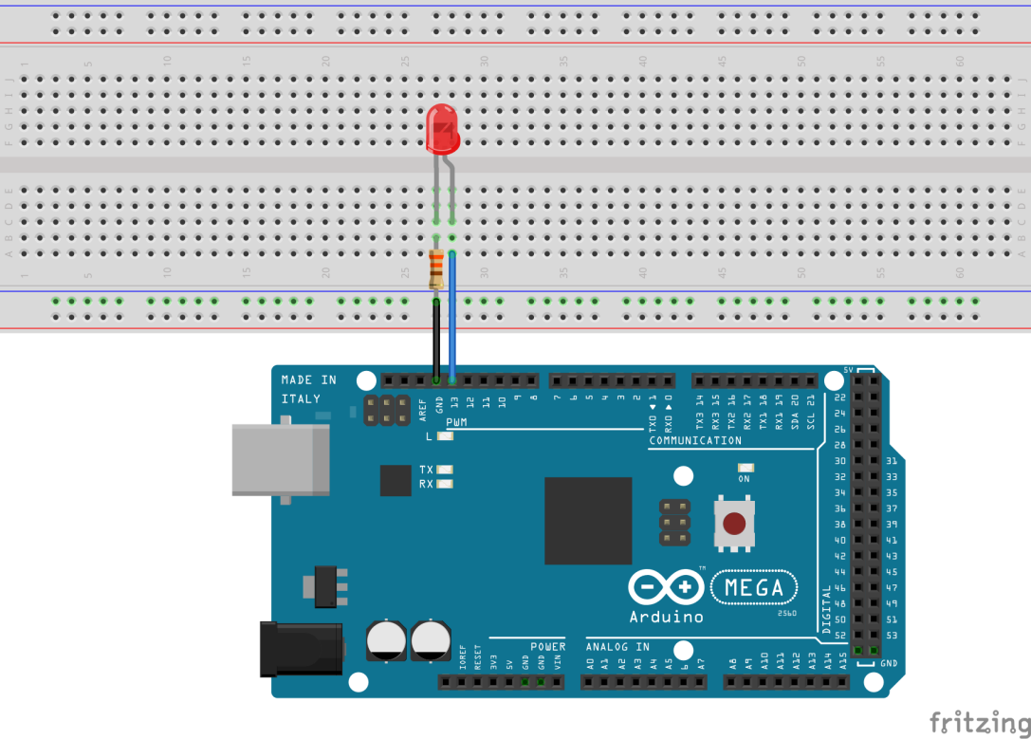

1. Sambungkan Board Arduino Mega 2560 ke PC / Laptop menggunakan kabel USB
2. Buka PC / Laptop buat 1 buah folder di dalam Document dengan nama : Robotika dan Otomasi.
3. Buka Arduino IDE, patikan tampilan nya akan tampak sebagai berikut:



1. ubah isi code program di atas dengan kede berikut:

void setup() {

pinMode(13, OUTPUT);

Serial.begin(9600);

}

void loop() {

digitalwrite(13, HIGH);

Serial.println(“LED ON”);

delay(1000);

digitalwrite(13, LOW);

Serial.println(“LED OFF”);

delay(1000);

}

1. Kemudian Klik File -> Save -> arahkan ke folder Robotika dan Otomasi, ubah nama file menjadi : praktikum 2
2. pastikan pemilihan board sudah sesuai : arduino mega 2560
3. pastikan pemilihan port yang terhubung sudah benar misalnya : COM5
4. upload code program dengan cara klik menu upload
5. perhatikan serial monitor untuk mengetahui apakah program berjalan dengan baik, jika serial monitor menunjukan keterangan sesuai dengan keadaan LED maka di pastikan praktikum 2 berhasil .
6. Analisis

lakukan langkah kegiatan di atas sebanyak minimal 5 kali percobaan kemudian isi analisa tabel berikut:

|  |  |  |  |
| --- | --- | --- | --- |
| No Percobaan | Waktu (Menit) | Keterangan (Sukses / Gagal) | Paraf Guru |
| 1 |  |  |  |
| 2 |  |  |  |
| 3 |  |  |  |
| 4 |  |  |  |
| 5 |  |  |  |
| 6 |  |  |  |
| 7 |  |  |  |
| 8 |  |  |  |
| 9 |  |  |  |
| 10 |  |  |  |

1. Kesimpulan

- - - - - - - - - - - - - - - - - - - - - - - - - - - - - - - - - - - - - - - - - - - - - - - - - - - - - - - - - - - - - - - - - - - - - - - - - - - - - - - - - - - - - - - - - - - - - - - - - - - - - - - - - - - - - - - - - - - - - - - - - - - - - - - - - - - - - - - - - - - - - - - - - - - - - - - - - - - - - - - - - - - - - - - - - - - - - - - - - - - - - - - - - - - - - - - - - - - - - - - - - - - - - - - - - - - - - - - - - - - - - - - - - - - - - - - - - - - - - - - - - - - - - - - - - - - - - - - - - - - - - - - - - - - - - - - - - - - - - - - - - - - - - - - - - - - - - - - - - - - - - - - - - - - - - - - - - - - - - - - - - - - - - - - - - - - - - - - - - - - - - - - - - - - - - - - - - - - - - - - - - - - - - - - - - - - - - - - - - - - - - - - - - - - - - - - - - - - - - - - - - - - - - - - - - - - - - - - - - - - - - - - - - - - - - - - - - - - - - - - - - - - - - - - - - - - - - - - - - - - - - - - - - - - - - - - - - - - - - - - - - - - - - - - -

**Variabel dan Konstanta**

1. Teori Dasar

Variable merupakan tempat penyimpanan suatu nilai, dan nilai yang ada padanya

dapat di ubah selam eksekusi program berlangsung, sedangkan konstanta adalah merupakan tempat penyimpanan suatu nilai namun nilai yang ada padanya tidak dapat di ubah atau bersifat tetap.

**17**

**12**

15

10

Variabel Konstanta

Adapun format dan contoh pendefinisian sebuah variabel adalah sebagai berikut:

**int pin_relay = 12;**

**tipe_data(spasi)nama_variabel = nilai;**

Adapun format dan contoh pendefinisian sebuah konstanta adalah sebagai berikut:

Format 1 :

**const int pin_led = 13;**

**const tipe_data(spasi)nama_konstatnta = nilai;**

Format 2 :

**#define PIN_LED 7**

**#define(spasi)NAMA_KONSTANTA(spasi)NILAI**

jenis-jenis tipe data dasar yang biasa digunakan sebagai berikut:

|  |  |  |
| --- | --- | --- |
| No | Tipe Data | Rentang Nilai |
| 1 | boolean | true dan false |
| 2 | char | -127 -> 128 |
| 3 | byte | 0 -> 255 |
| 4 | int | -32768 -> 32768 |
| 5 | long | -2147483648 -> -2147483648 |
| 6 | float | -3.4028235E+38 -> 3.402835E+38 |
| 7 | string | dibangun dari susunan karakter |

1. Pertanyaan Siswa

_ _ _ _ _ _ _ _ _ _ _ _ _ _ _ _ _ _ _ _ _ _ _ _ _ _ _ _ _ _ _ _ _ _ _ _ _ _ _ _ _ _ _ _ _ _ _ _ _ _ _ _ _ _ _ _ _ _ _ _ _ _ _ _ _ _ _ _ _ _ _ _ _ _ _ _ _ _ _ _ _ _ _ _ _ _ _ _ _ _ _ _ _ _ _ _ _ _ _ _ _ _ _ _ _ _ _ _ _ _ _ _ _ _ _ _ _ _ _ _ _ _ _ _ _ _ _ _ _ _ _ _ _ _ _ _ _ _ _ _ _ _ _ _ _ _ _ _ _ _ _ _ _ _ _ _ _ _ _ _ _ _ _ _ _ _ _ _ _ _ _ _ _ _ _ _ _ _ _ _ _ _ _ _ _ _ _ _ _ _ _ _ _ _ _ _ _ _ _ _ _ _ _ _ _ _ _ _ _ _ _ _ _ _ _ _ _ _ _ _ _ _ _ _ _ _ _ _ _ _ _ _ _ _ _ _ _ _ _ _ _ _ _ _ _ _ _ _ _ _ _ _ _ _ _ _ _ _ _ _ _ _ _ _ _ _ _ _ _ _ _ _ _ _ _ _ _ _ _ _ _ _ _ _ _ _ _ _ _ _ _ _ _ _ _ _ _ _ _ _ _ _ _ _ _ _ _ _ _ _ _ _ _ _ _ _ _ _ _ _ _ _ _ _ _ _ _ _ _ _ _ _ _ _ _ _ _ _ _ _ _ _ _ _ _ _ _ _ _ _ _ _ _ _ _ _ _ _ _ _ _ _ _ _ _ _ _ _ _ _ _ _ _ _ _ _ _ _ _ _ _ _ _ _ _ _ _ _ _ _ _ _ _ _ _ _ _ _ _ _ _ _ _ _ _ _ _ _ _ _ _ _ _ _ _ _ _ _ _ _ _ _ _ _ _ _ _ _ _ _ _ _ _ _ _ _ _ _ _ _ _ _ _ _ _ _ _ _ _ _ _ _ _ _ _ _ _ _ _ _ _ _ _ _ _ _ _ _ _ _ _ _ _ _ _ _ _ _ _ _ _ _ _ _ _ _ _ _ _ _ _ _ _ _ _ _ _ _ _ _ _ _ _ _ _ _ _ _ _ _ _ _ _ _

**Praktekum 3**

**Button dan LED**

1. Environment

Arduino Mega 2560 1 buah LED Switch Button

Kabel Jumper Resistor 330 Ohm PC / Laptop

Ardino IDE

1. Langkah Kegiatan
2. Lakukan wiring rangkaian seperti tampak pada gambar berikut:

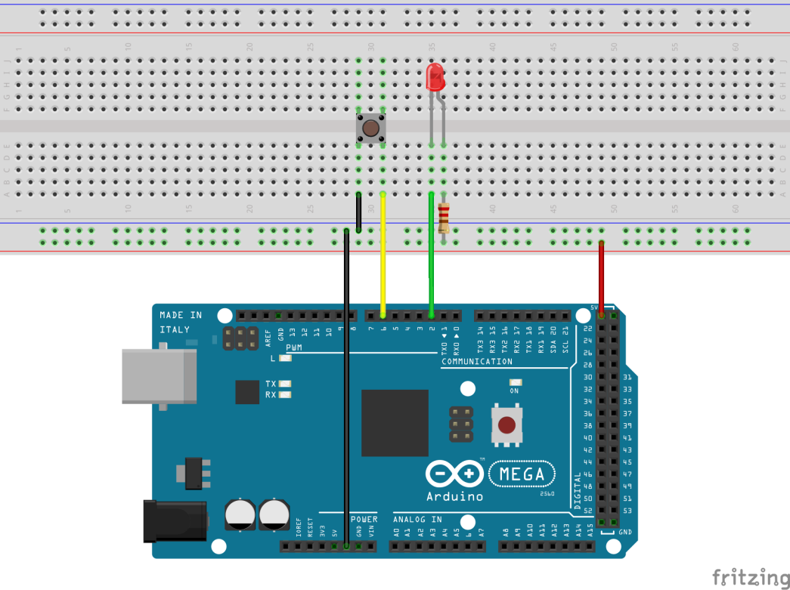

1. Sambungkan Board Arduino Mega 2560 ke PC / Laptop menggunakan kabel USB
2. Buka PC / Laptop buat 1 buah folder di dalam Document dengan nama : Robotika dan Otomasi.
3. Buka Arduino IDE, pastikan tampilannya akan tampak sebagai berikut:



1. ubah isi code program di atas dengan kede berikut:

#define BTN 6

#define LED 2

void setup() {

pinMode(LED, OUTPUT);

pinMode(BTN, INPUT_PULLUP);

}

void loop() {

boolean led_state = digitalRead(BTN);

digitalWrite(LED, led_state);

}

1. Kemudian Klik File -> Save -> arahkan ke folder Robotika dan Otomasi, ubah nama file menjadi : praktikum 3
2. pastikan pemilihan board sudah sesuai : arduino mega 2560
3. pastikan pemilihan port yang terhubung sedah benar misalnya : COM5
4. upload code program dengan cara klik menu upload
5. lakukan penekanan pada tombol button jika button ditekan dan menunjukan led menyala maka dipastikan praktikum 3 berhasil .
6. Analisis

lakukan langkah kegiatan di atas sebanyak minimal 5 kali percobaan kemudian isi analisa tabel berikut:

|  |  |  |  |
| --- | --- | --- | --- |
| No Percobaan | Waktu (Menit) | Keterangan (Sukses / Gagal) | Paraf Guru |
| 1 |  |  |  |
| 2 |  |  |  |
| 3 |  |  |  |
| 4 |  |  |  |
| 5 |  |  |  |
| 6 |  |  |  |
| 7 |  |  |  |
| 8 |  |  |  |
| 9 |  |  |  |
| 10 |  |  |  |

1. Kesimpulan

- - - - - - - - - - - - - - - - - - - - - - - - - - - - - - - - - - - - - - - - - - - - - - - - - - - - - - - - - - - - - - - - - - - - - - - - - - - - - - - - - - - - - - - - - - - - - - - - - - - - - - - - - - - - - - - - - - - - - - - - - - - - - - - - - - - - - - - - - - - - - - - - - - - - - - - - - - - - - - - - - - - - - - - - - - - - - - - - - - - - - - - - - - - - - - - - - - - - - - - - - - - - - - - - - - - - - - - - - - - - - - - - - - - - - - - - - - - - - - - - - - - - - - - - - - - - - - - - - - - - - - - - - - - - - - - - - - - - - - - - - - - - - - - - - - - - - - - - - - - - - - - - - - - - - - - - - - - - - - - - - - - - - - - - - - - - - - - - - - - - - - - - - - - - - - - - - - - - - - - - - - - - - - - - - - - - - - - - - - - - - - - - - - - - - - - - - - - - - - - - - - - - - - - - - - - - - - - - - - - - - - - - - - - - - - - - - - - - - - - - - - - - - - - - - - - - - - - - - - - - - - - - - - - - - - - - - - - - - - - - - - - - - - - -

**Percabangan**

1. **Teori Dasar**

percabangan merupakan pemilihan pernyataan (*statements*) yang akan di eksekusi dimana pilihan tersebut didasarkan atas kondisi, dimana hasil ungkapan kondisi didapat dari operator relasi atau operator logika.



**Operator Relasi**

Operator relasi merupakan ungkapan kondisi yang digunakan untuk membandingkan dua buah nilai. Hasil dari ungkapan ini bernilai 1 (benar) atau 0 (salah). Adapun operator relasi dapat dilihat pada Tabel berikut.

|  |  |  |
| --- | --- | --- |
| **Operator** | **Keterangan** | **Contoh** |
| == | Sama dengan (bukan penugasan) | x==y |
| != | Tidak sama dengan | x!=y |
| > | Lebih dari | x>y |
| < | Kurang dari | x<y |
| >= | lebih atau sama dengan | x>=y |
| <= | Kurang atau sama dengan | x<=y |

O**perator Logika**

Operator logika biasa digunakan untuk menghubungkan dua buah ungkapan kondisi menjadi sebuah ungkapan kondisi.

|  |  |  |
| --- | --- | --- |
| **Operator** | **Keterangan** | **Contoh** |
| and | Logika AND | (x==y) and (x<=y) |
| or | Logika OR | (x==y) or (x<=y) |
| not | Logika NOT | not (x>y) |

**Jenis Percabangan**

1. Percabangan (if) sederhana

Merupakan jenis percangan dimana pernyataan akan di jalankan jika kondisi benar jika sebaliknya maka pernyataan akan di abaikan. besrikut adalah format penulisannya:

if(kondisi)

pernyataan

if(kondisi){

pernyataan1

pernyataan2

}

atau

1. Percabangan (if else)

Merupakan jenis percangan dimana jika kondisi benar maka kan menjalankan pernyataan yang benar, jika salah maka akan menjalankan pernyataan yang salah. berikut adalah format penulisannya:

if(kondisi){

pernyataan benar1

pernyataan benar2

}else{

pernyataan salah1

pernyataan salah2

}

if(kondisi)

pernyataan benar

else

pernyataan salah

1. Percabangan (if else if ... else)

Merupakan jenis percangan yang memiliki banyak kondisi, dimanan pernyataan akan dijalankan berdasarkan salah satu kondisi yang benar jika semua kondisi salah maka pernyataan yang salah akan dijalankan. berikut adalah format penulisannya:

if(kondisi){

pernyataan benar1

pernyataan benar2

}else if(kondisi2){

pernyataan benar1

pernyataan benar2

}else if(kondisi3){

pernyataan benar1

pernyataan benar2

}else{

pernyataan salah1

pernyataan salah2

}

if(kondisi1)

pernyataan benar1

else if(kondisi2)

pernyataan benar2

else if (kondisi3)

pernyataan benar3

else

pernyataan salah

1. **Pertanyaan Siswa**

_ _ _ _ _ _ _ _ _ _ _ _ _ _ _ _ _ _ _ _ _ _ _ _ _ _ _ _ _ _ _ _ _ _ _ _ _ _ _ _ _ _ _ _ _ _ _ _ _ _ _ _ _ _ _ _ _ _ _ _ _ _ _ _ _ _ _ _ _ _ _ _ _ _ _ _ _ _ _ _ _ _ _ _ _ _ _ _ _ _ _ _ _ _ _ _ _ _ _ _ _ _ _ _ _ _ _ _ _ _ _ _ _ _ _ _ _ _ _ _ _ _ _ _ _ _ _ _ _ _ _ _ _ _ _ _ _ _ _ _ _ _ _ _ _ _ _ _ _ _ _ _ _ _ _ _ _ _ _ _ _ _ _ _ _ _ _ _ _ _ _ _ _ _ _ _ _ _ _ _ _ _ _ _ _ _ _ _ _ _ _ _ _ _ _ _ _ _ _ _ _ _ _ _ _ _ _ _ _ _ _ _ _ _ _ _ _ _ _ _ _ _ _ _ _ _ _ _ _ _ _ _ _ _ _ _ _ _ _ _ _ _ _ _ _ _ _ _ _ _ _ _ _ _ _ _ _ _ _ _ _ _ _ _ _ _ _ _ _ _ _ _ _ _ _ _ _ _ _ _ _ _ _ _ _ _ _ _ _ _ _ _ _ _ _ _ _ _ _ _ _ _ _ _ _ _ _ _ _ _ _ _ _ _ _ _ _ _ _ _ _ _ _ _ _ _ _ _ _ _ _ _ _ _ _ _ _ _ _ _ _ _ _ _ _ _ _ _ _ _ _ _ _ _ _ _ _ _ _ _ _ _ _ _ _ _ _ _ _ _ _ _ _ _ _ _ _ _ _ _ _ _ _ _ _ _ _ _ _ _ _ _ _ _ _ _ _ _ _ _ _ _ _ _ _ _ _ _ _ _ _ _ _ _ _ _ _ _ _ _ _ _ _ _ _ _ _ _ _ _ _ _ _ _ _ _ _ _ _ _ _ _ _ _ _ _ _ _ _ _ _ _ _ _ _ _ _ _ _ _ _ _ _ _ _ _ _ _ _ _ _ _ _ _ _ _ _ _ _ _ _ _ _ _ _ _ _ _ _ _ _ _ _ _ _ _ _ _ _ _ _ _ _ _ _ _ _ _ _ _ _ _ _ _ _ _ _ _ _ _ _ _ _ _ _ _ _ _ _ _ _ _ _ _ _ _ _ _ _ _ _ _ _ _ _ _ _ _ _ _ _ _ _ _ _ _ _ _ _ _ _ _ _ _ _ _ _ _ _ _ _ _ _ _ _ _ _ _ _ _ _ _ _ _ _ _ _ _ _ _ _ _ _ _ _ _ _ _ _ _ _ _ _ _ _ _ _ _ _ _ _ _ _ _ _ _ _ _ _ _ _ _ _ _ _ _ _ _ _ _ _ _ _ _ _ _ _ _ _ _ _ _ _ _ _ _ _ _ _ _ _ _ _ _ _ _ _ _ _ _ _ _ _ _ _ _ _ _ _ _ _ _ _ _ _ _ _ _ _ _ _ _ _ _ _ _ _ _ _ _ _ _ _ _ _ _ _ _ _ _ _ _ _ _ _ _ _ _ _ _ _ _ _ _ _ _ _ _ _ _ _ _

**Project 1**

**Kendali Sepeda Motor Mengguakan Android**

1. **Environment**

Arduino Mega 2560 Modul Bluetooth HC-05

Kabel 3 m PC / Laptop

Modul Relay 2 CH Arduino IDE

1. **Wiring**

**accu**

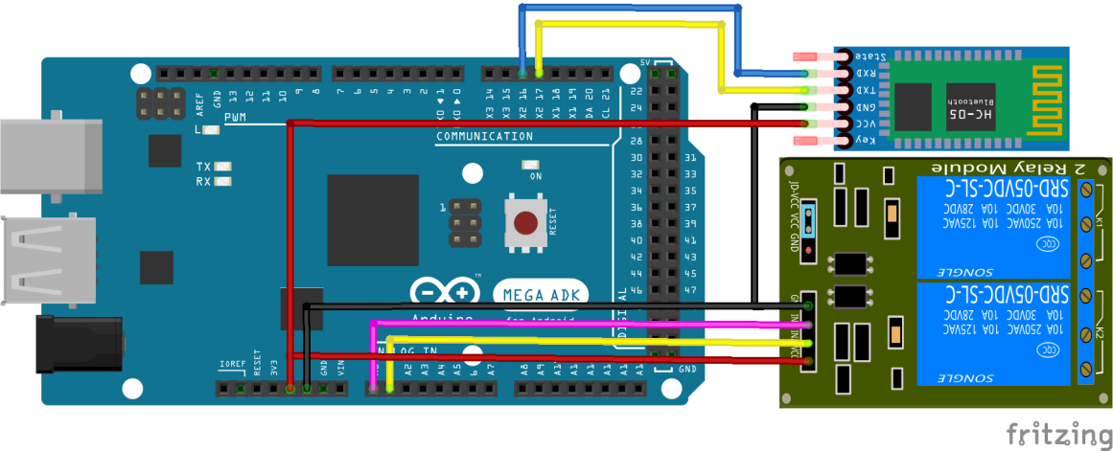

**STARTER**

KOTAK

1. **Kode Program**

#define PIN_STARTER A0

#define PIN_KONTAK A1

#define ON LOW

#define OFF HIGH

void setup() {

Serial2.begin(9600);

pinMode(PIN_STARTER,OUTPUT);

pinMode(PIN_KONTAK, OUTPUT);

digitalWrite(PIN_STARTER, OFF);

digitalWrite(PIN_KONTAK, OFF);

}

void loop() {

if(Serial2.available()>0){

char data = Serial2.read();

if(data == 'A'){

digitalWrite(PIN_KONTAK, ON);

}else if(data == 'B'){

digitalWrite(PIN_STARTER, ON);

delay(1000);

digitalWrite(PIN_STARTER, OFF);

}else if(data == 'a'){

digitalWrite(PIN_STARTER, OFF);

digitalWrite(PIN_KONTAK, OFF);

}

}

}

**Perulangan (Loop)**

1. **Teori Dasar**

Perulangan adalah proses mengulang-ulang eksekusi kode program tanpa henti, selama kondisi yang dijadikan acuan terpenuhi. Adapun bentuk perulangan arduino diantaranya :

1. **Didalam fungsi loop()**

Dengan menempatkan code program (pernyataan) di dalam fingsi loop (void loop()) maka secara otomatis pernyataan tersebut akan di lakukan perulangan tampa henti selama catu daya di berikan pada arduino. perhatikan contoh berikut :

void setup() {

Serial.begin(9600);

}

void loop() {

Serial.println("Hallo.!");

delay(1000);

}

Hasil eksekusi code program di samping akan menampilakan text “hello.!” secara berulang-ulang pada serial monitor selama catu daya masih di berikan.

1. **Perulangan While**

merupakan jenis perulangan untuk dapat melakukan siklus perulangan berdasarkan suatu kondisi. dimana kondisi ini akan menentukan pernyataan yang ada di dalamnya di eksekusi. perhatikan format penulisan while sebagai berikut:

int a = 0;

while(A<10){

Serial.println("Hallo.!");

delay(1000);

a++;

}

while(Kondisi){

pernyataan1;

pernyataan2;

.....

pernyataanN;

}

contoh

dari contoh kode di atas akan melakukan perulangan selama kondisi nilai A < 10 yaitu ada 10 kali perulangan.

1. **Perulangan for**

merupakan jenis perulangan yang harus memenuhi 3 aspek, dimana 3 aspek tersebut menentukan seberapa banyak perulangan akan dilakukan. dianyanya :

* Nilai awal
* Kondisi
* Pencacah

perhatikan format penulisan while sebagai berikut:

for(int i=0;i<10;i++){

Serial.println("Hallo.!");

delay(1000);

}

for(nilai_awal;Kondisi;Pencacah){

pernyataan1;

pernyataan2;

.....

pernyataanN;

}

**Praktekum 4**

**Led Multiple Blink**

1. Environment

Arduino Mega 2560 2 buah LED PC / Laptop

Kabel Jumper 2 Resistor 330 Ohm Ardino IDE

1. Langkah Kegiatan
2. Lakukan wiring rangkaian seperti tampak pada gambar berikut:

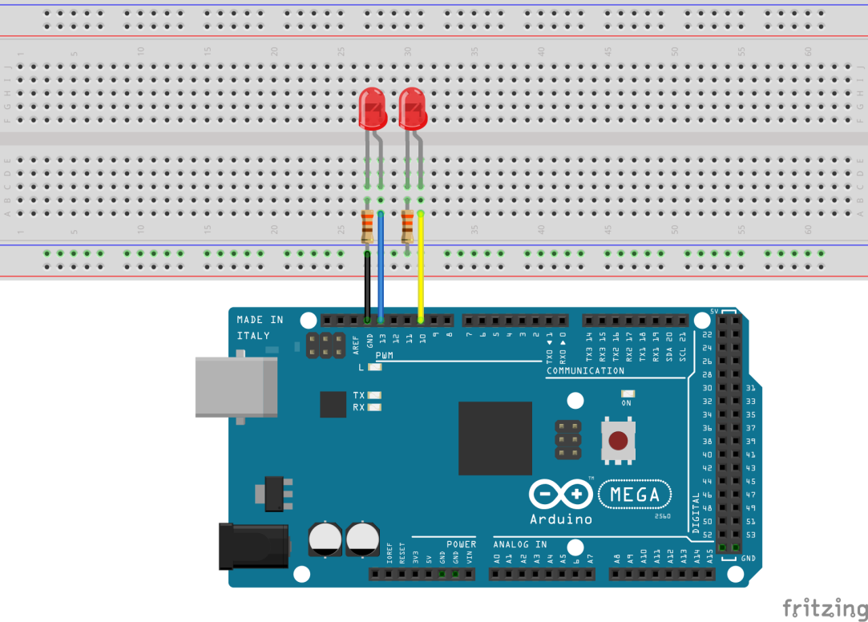

1. Sambungkan Board Arduino Mega 2560 ke PC / Laptop menggunakan kabel USB
2. Buka PC / Laptop buat 1 buah folder di dalam Document dengan nama : Robotika dan Otomasi.
3. Buka Arduino IDE, pastikan tampilannya akan tampak sebagai berikut:



1. ubah isi code program di atas dengan kede berikut:

#define LED1 13

#define LED2 10

void setup() {

pinMode(LED1, OUTPUT);

pinMode(LED2, OUTPUT);

Serial.begin(9600);

}

void loop() {

int x = 1;

while(x<11) {

digitalWrite(LED1, HIGH);

Serial.print(“LED1 ON KE ”);

Serial.println(x);

delay(1000)

digitalWrite(LED1, LOW);

x++;

}

for(int i=1;i<6;i++){

digitalWrite(LED2, HIGH);

Serial.print(“LED2 ON KE ”);

Serial.println(x);

delay(1000)

digitalWrite(LED2, LOW);

}

}

1. Kemudian Klik File -> Save -> arahkan ke folder Robotika dan Otomasi, ubah nama file menjadi : praktikum4
2. pastikan pemilihan board sudah sesuai : arduino mega 2560
3. pastikan pemilihan port yang terhubung sedah benar misalnya : COM5
4. upload code program dengan cara klik menu upload
5. perhatikan serial monitor untuk mengetahui apakah program berjalan dengan baik, jika serial monitor menunjukan keterangan sesuai dengan keadaan LED maka di pastikan praktikum 4 berhasil .
6. Analisis

lakukan langkah kegiatan di atas sebanyak minimal 5 kali percobaan kemudian isi analisa tabel berikut:

|  |  |  |  |
| --- | --- | --- | --- |
| No Percobaan | Waktu (Menit) | Keterangan (Sukses / Gagal) | Paraf Guru |
| 1 |  |  |  |
| 2 |  |  |  |
| 3 |  |  |  |
| 4 |  |  |  |
| 5 |  |  |  |
| 6 |  |  |  |

1. Kesimpulan

- - - - - - - - - - - - - - - - - - - - - - - - - - - - - - - - - - - - - - - - - - - - - - - - - - - - - - - - - - - - - - - - - - - - - - - - - - - - - - - - - - - - - - - - - - - - - - - - - - - - - - - - - - - - - - - - - - - - - - - - - - - - - - - - - - - - - - - - - - - - - - - - - - - - - - - - - - - - - - - - - - - - - - - - - - - - - - - - - - - - - - - - - - - - - - - - - - - - - - - - - - - - - - - - - - - - - - - - - - - - - - - - - - - - - - - - - - - - - - - - - - - - - - - - - - - - - - - - - - - - - - - - - - - - - - - - - - - - - - - - - - - - - - - - - - - - - - - - - - - - - - - - - - - - - - - - - - - - - - - - - - - - - - - - - - - - - - - - - - - - - - - - - - - - - - - - - - - - - - - - - - - - - - - - - - - - - - - - - - - - - - - - - - - - - - - - - - - - - - - - - - - - - - - - - - - - - - - - - - - - - - - - - - - - - - - - - - - - - - - - - - - - - - - - - - - - - - - - - - - - - - - - - - - - - - - - - - - - - - - - - - - - - - - -